VVIP :
Example 1: Login Functionality (Passed Test Case)
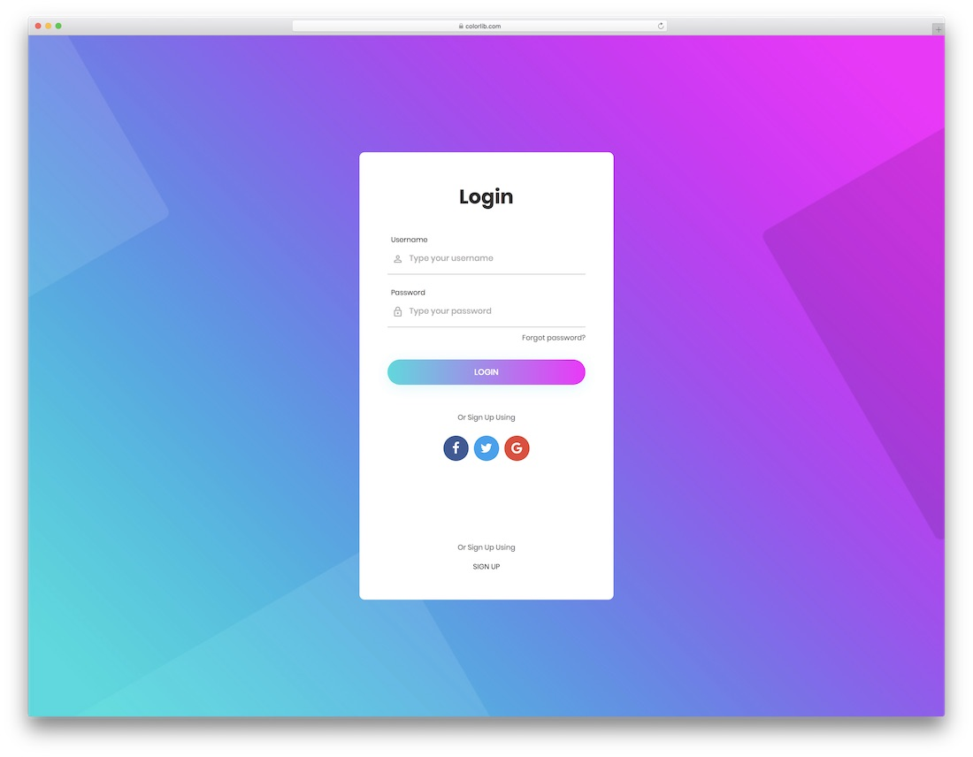
Field | Details
Test Case ID | TC001
Test Scenario | Verify that the user can successfully log in with valid credentials.
Preconditions | User must be registered in the system and login page must be accessible.
Test Steps | 1. Open the application login page.  2. Enter valid username: user123.  3. Enter valid password: Password@123.  4. Click the “Login” button.
Test Data | Username = user123  Password = Password@123
Expected Result | The user should be redirected to the dashboard/home page.
Actual Result | The user successfully logged in and was redirected to the dashboard.
Status | ✅ PASS
Explanation:
The actual result matched the expected behavior — the user could log in successfully. Therefore, the test case is marked as Pass.
Example: In a mobile banking app, this confirms that the login function works properly with correct credentials.

Example 2: Login Functionality (Passed Test Case with invalid username is entered)

Field | Details
Test Case ID | TC002
Test Scenario | Verify that login fails when an invalid username is entered.
Preconditions | The user account (user123) must exist.
Test Steps | 1. Open the application login page.  2. Enter valid username: Wrong123. (wrong)  3. Enter valid password: Password@123.  4. Click the “Login” button.
Test Data | Username = Wrong123  Password = Password@123
Expected Result | The system should display an error message: “Invalid username” and not allow login.
Actual Result | The user was not redirected to the home page with error message.
Status | ✅ PASSss

Example 3: Login Functionality (Passed Test Case with invalid Password is entered)

Field | Details
Test Case ID | TC003
Test Scenario | Verify that login fails when an invalid password is entered.
Preconditions | The user account (user123) must exist.
Test Steps | 1. Open the application login page.  2. Enter valid username: user123.  3. Enter valid password: wrong@123. (wrong)  4. Click the “Login” button.
Test Data | Username = user123  Password = wrong @123
Expected Result | The system should display an error message: “Invalid password” and not allow login.
Actual Result | The user was not redirected to the home page with error message.
Status | ✅ PASS

❌ Example 4: Login Functionality (Failed Test Case)
Field | Details
Test Case ID | TC0044
Test Scenario | Verify that login fails when an invalid password is entered.
Preconditions | The user account (user123) must exist.
Test Steps | 1. Open the login page.  2. Enter username: user123.  3. Enter password: WrongPass@123.  4. Click the “Login” button.
Test Data | Username = user123  Password = WrongPass@123
Expected Result | The system should display an error message: “Invalid username or password.” and not allow login.
Actual Result | The user was redirected to the home page without any error message.
Status | ❌ FAIL
Explanation:
The actual result did not match the expected result — the system incorrectly allowed access with an invalid password. This indicates a defect or security bug in the login module.
Example: In an e-commerce website, this failure would be critical because it compromises user data security.

These examples show how test cases are evaluated:
- PASS → Expected and actual outcomes match.
- FAIL → Expected and actual outcomes differ, signaling a bug that must be reported and fixed.

VIIP
Q.2 Prepare test cases for a “Registration Form” that includes fields like Name, Email, Password, and Confirm Password.
Test Case ID | Test Scenario | Test Steps | Input Data | Expected Result | Actual Result | Type
TC01 | Verify registration with all valid inputs | Enter valid Name, Email, Password, Confirm Password → Click “Submit” | Name: John Doe Email: john@gmail.com Password: John@123 Confirm Password: John@123 | Should be Registration successful; success message displayed or redirected to login page | Registration successful; success message displayed or redirected to login page | Positive
TC02 | Verify Name field accepts alphabets only | Enter numbers/special characters in Name field | Name: John123 | Should be Error message: “Name should contain only alphabets” | Error message: “Name should contain only alphabets” | Negative
TC03 | Verify Name field is mandatory | Leave Name field blank | Email: abc@gmail.com Password: Abc@123 Confirm Password: Abc@123 | Should be Error Should be message: “Name is required” | Error message: “Name is required” | Negative
TC04 | Verify valid Email format | Enter correctly formatted email | Email: test.user@gmail.com | Should be Accepted successfully | Accepted successfully | Positive
TC05 | Verify invalid Email format | Enter incorrect email format | Email: usergmail.com | Should be Error message: “Invalid email address” | Error message: “Invalid email address” | Negative
TC06 | Verify Email field is mandatory | Leave Email field blank | Email: (blank) | Should be Error message: “Email is required” | Error message: “Email is required” | Negative
TC07 | Verify Password field accepts valid input | Enter valid password meeting policy | Password: Abc@123 | Should be Accepted successfully | Accepted successfully | Positive
TC08 | Verify Password minimum length requirement | Enter password less than required length (e.g., 6 chars) | Password: Ab@12 | Should be Error: “Password must be at least 8 characters” | Error: “Password must be at least 8 characters” | Negative
TC09 | Verify Password complexity (must include uppercase, lowercase, digit, special char) | Enter password not meeting policy | Password: abc12345 | Should be Error: “Password must include uppercase, lowercase, digit, and special character” | Error: “Password must include uppercase, lowercase, digit, and special character” | Negative
TC10 | Verify Confirm Password matches Password | Enter same passwords | Password: Test@123 Confirm Password: Test@123 | Should be Accepted successfully | Accepted successfully | Positive
TC11 | Verify Confirm Password mismatch | Enter different passwords | Password: Test@123 Confirm Password: Test@321 | Should be Error: “Passwords do not match” | Error: “Passwords do not match” | Negative
TC12 | Verify all mandatory fields validation | Leave all fields blank and click “Submit” | Blank form | Should be Error messages displayed for all required fields | Error messages displayed for all required fields | Negative
TC13 | Verify trimming of spaces in input | Enter extra spaces before/after Name or Email | Name: * John Doe * Email: * john@gmail.com * | Should be System trims extra spaces and accepts valid data | System trims extra spaces and accepts valid data | Positive
TC14 | Verify Email uniqueness (duplicate email check) | Try registering with existing email | Email: john@gmail.com (already registered) | Should be Error: “Email already exists” | Error: “Email already exists” | Negative
TC15 | Verify password masking | Check if password and confirm password fields show dots/asterisks instead of text | Type Abc@123 | Should be Password hidden (masked) | Password hidden (masked) | Positive
TC16 | Verify field length boundaries | Enter very long values beyond allowed length | Name: 300 characters | Should be Error: “Input exceeds maximum length” | Error: “Input exceeds maximum length” | Negative
TC17 | Verify successful redirection after registration | Register with valid details | Valid inputs | Should be User redirected to login/welcome page | User redirected to login/welcome page | Positive
TC18 | Verify form reset functionality | Click on “Reset” button after entering details | Filled form → Click Reset | Should be All fields cleared | All fields cleared | Positive
TC19 | Verify special character handling in name | Enter special characters in name | Name: @John! | Should be Error: “Name cannot contain special characters” | Error: “Name cannot contain special characters” | Negative
TC20 | Verify error messages are user-friendly | Trigger validation errors | Invalid input combinations | Should be Clear, readable error messages shown below each field | Clear, readable error messages shown below each field | Positive

